[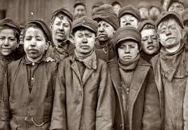](https://vedazive.cz/wp-content/uploads/2022/07/prace-deti-spinave.jpg)

Obr. č. 1

[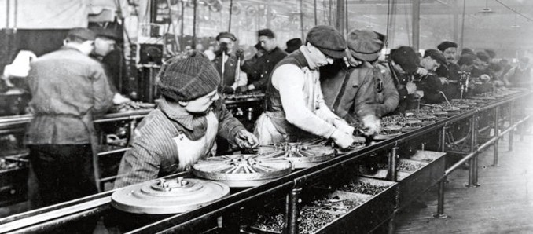](https://miro.medium.com/v2/resize:fit:720/format:webp/0*SQ07IvhEUyN6DScv.)

Obr. č. 2

[](https://www.google.cz/url?sa=i&rct=j&q=&esrc=s&source=images&cd=&cad=rja&uact=8&ved=2ahUKEwirw5_Hr6ngAhUCblAKHcGjD9sQjRx6BAgBEAU&url=https://www.alamy.com/stock-photo-james-watt-1736-1819-was-a-scottish-inventor-and-mechanical-engineer-103996888.html&psig=AOvVaw0C9TEs_2zo84E2T7Gh7dQj&ust=1549620277548271)[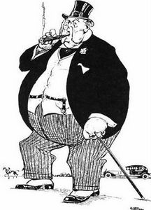](https://blogger.googleusercontent.com/img/b/R29vZ2xl/AVvXsEju7VGX2ie4xdDdMfi3GDtzjXKTfa9sz0DFp6dVFd0ajhsfdjUqD7lik6bqVD9KGVaumn3f_sRlkk6k4MPdF-oLLHsFMQ6V38E9ikp3Gcb3r9hPQLDXLIha_qY3b-0G_6qmdI3w2zJQf8o/s1600/kapitalista_01.jpg)

Obr. č. 3

Obr. 4

Zdroje obrázků:

Obr. č. 1 - *Dětští horníci*. Online. In: Věda živě.cz. 2022. Dostupné z: <https://vedazive.cz/wp-content/uploads/2022/07/prace-deti-spinave.jpg>. [cit. 2025-07-04].

Obr. č. 2 - *Dělníci u pasové výroby Henryho Forda*. Online. In: Medium.com. 2017. Dostupné z: [https://miro.medium.com/v2/resize:fit:720/format:webp/0*SQ07IvhEUyN6DScv.](https://miro.medium.com/v2/resize:fit:720/format:webp/0*SQ07IvhEUyN6DScv.). [cit. 2025-07-04].

Obr. č. 3 - *Karikatura kapitalisty v časopisu Dikobraz*. Online. In: Enzmannova archa.com. 2012. Dostupné z: <https://blogger.googleusercontent.com/img/b/R29vZ2xl/AVvXsEju7VGX2ie4xdDdMfi3GDtzjXKTfa9sz0DFp6dVFd0ajhsfdjUqD7lik6bqVD9KGVaumn3f_sRlkk6k4MPdF-oLLHsFMQ6V38E9ikp3Gcb3r9hPQLDXLIha_qY3b-0G_6qmdI3w2zJQf8o/s1600/kapitalista_01.jpg>. [cit. 2025-07-04].

Obr. 4. - *James Watt*. Online. In: Alamy.com. 2025. Dostupné z: <https://www.alamy.com/stock-photo-james-watt-1736-1819-was-a-scottish-inventor-and-mechanical-engineer-103996888.html>. [cit. 2025-07-04].