[](http://www.google.cz/url?sa=i&rct=j&q=&esrc=s&source=images&cd=&ved=2ahUKEwjcmtzHrangAhUDJVAKHWtgCM4QjRx6BAgBEAQ&url=http://www.truhla.cz/predmety/dejepis/prezentace/sexta/Prumyslova_revoluce.pdf&psig=AOvVaw1i-IWhT5XkCxgL_UhmnduF&ust=1549619746866648)

[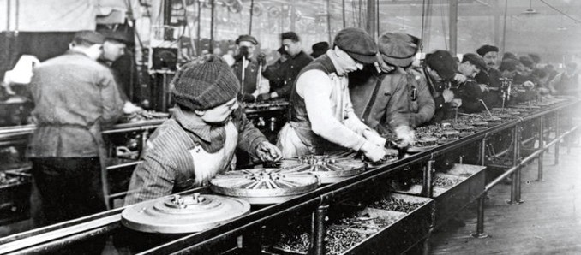](https://www.google.cz/url?sa=i&rct=j&q=&esrc=s&source=images&cd=&cad=rja&uact=8&ved=2ahUKEwj_yvj5rangAhWQJ1AKHSChCOQQjRx6BAgBEAU&url=https://medium.com/edtech-kisk/pr%C5%AFmysl-4-0-506be74cd6c6&psig=AOvVaw1i-IWhT5XkCxgL_UhmnduF&ust=1549619746866648)

[](https://www.google.cz/url?sa=i&rct=j&q=&esrc=s&source=images&cd=&cad=rja&uact=8&ved=2ahUKEwirw5_Hr6ngAhUCblAKHcGjD9sQjRx6BAgBEAU&url=https://www.alamy.com/stock-photo-james-watt-1736-1819-was-a-scottish-inventor-and-mechanical-engineer-103996888.html&psig=AOvVaw0C9TEs_2zo84E2T7Gh7dQj&ust=1549620277548271)

[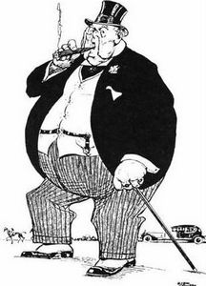](http://www.google.cz/url?sa=i&rct=j&q=&esrc=s&source=images&cd=&cad=rja&uact=8&ved=2ahUKEwiRjp-Pr6ngAhVIalAKHfzaCvcQjRx6BAgBEAU&url=http://enzmannovaarcha.blogspot.com/2012/10/kapitalismus-co-to-je.html&psig=AOvVaw1IehGphUeQzGEtJ9j21amn&ust=1549620157143199)